

SARAH COVID-19 UPDATES

PROJECT REPORT



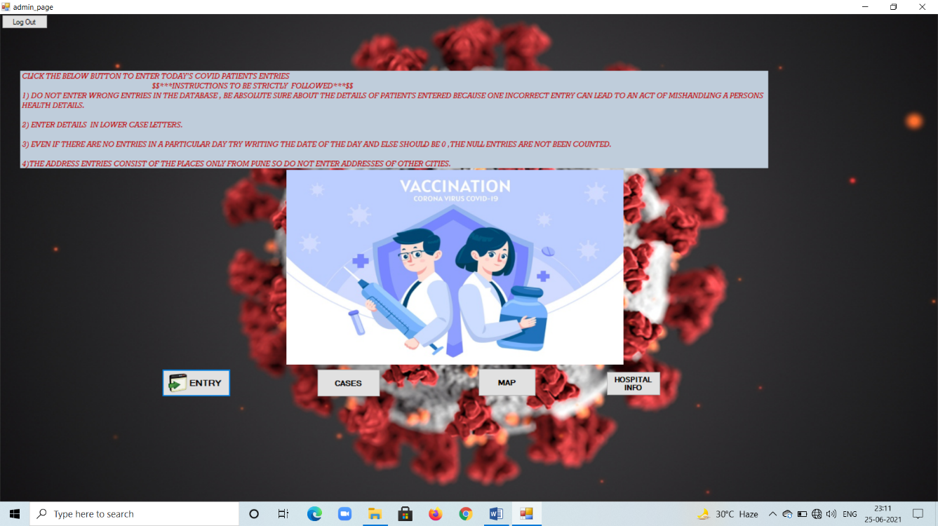

June 26, 2021

SARAH PVT LTD



**Department of Computer Engineering**

**A MINI PROJECT REPORT ON**

“**SARAH COVID – 19 UPDATES”**

SUBMITTED TO THE DEPARTMENT OF COMPUTER ENGINEERING

AISSMS IOIT

**SE COMPUTER ENGINEERING**

##### SUBMITTED BY

**STUDENT NAME ROLL NO**

**SHRIYASH BAND 56**

**ANISH DHAWALIKAR 60**

**HIMANK TYAGI 63**

**RUTUL WABLE 73**

**AKANKSHA SHELKE 74**

**

## 2020 -2021



**Department of Computer Engineering**

**CERTIFICATE**

This is to certify that the project report

“**SARAH COVID – 19 UPDATES”**

Submitted by

STUDENT NAME ROLL NO

**SHRIYASH BAND 56**

**ANISH DHAWALIKAR 60**

**HIMANK TYAGI 63**

**RUTUL WABLE 73**

**AKANKSHA SHELKE 74**

are the bonafide students of this institute and the work has been carried out by them under the supervision of **Prof. NEHA PATIL** and it is approved for the partial fulfillment of the Department of Computer Engineering AISSMS IOIT.

(**Prof** **NEHA PATIL**) (**Dr. S. N. Zaware**)

Guide Head,

Department of Computer Engineering Department of Computer Engineering

Place: Pune

Date:

**ABSTRACT**

Corona-Virus or Covid-19 has created a huge requirement for the health industry in terms of its operation and Medi-Care providing facilities. This Virus resulted in shortage of medical facilities, and creation of a huge burden on the technology.

Various ideas have been come up to meet these requirements and our idea is one of them. This system helps in creating a database for covid-19 patients and helps in tracking the spread of corona virus. The project can prove helpful in terms of providing better and reliable knowledge to the public.

Project deals with the concepts of computer engineering and utilizes them for its implementation. It includes subjects like, Fundamentals of data structure, object-oriented programming, digital electronics and logic design, computer graphics and mathematics.

The cores of this project are held with deep concepts of data structure and object oriented-programming. It also provides a dynamic look for its users and trust worthy knowledge. It is a small attempt to provide service to the public, in days of this pandemic.

This project is been developed and implemented by the students of SE Comp department of AISSMS IOIT. Due to their hard work and dedication the project is successful in implementing a software, which helps the society for its betterment and survival.

**TABLE OF CONTENTS**

1. OBJECTIVES

2. CONTROL WORK FLOW

3. ALGORITHM

4. FUNDAMENTALS OF DATA STRUCTURE:

4.1. SINGLE LINKED LIST

4.2 ARRAYS

5. DIGITAL ELECTRONICS AND LOGIC DESIGN:

5.1 BINARY ADDITION/SUBTRACTION

5.2 DECIMAL TO BCD CONVERSION

5.3 BCD TO DECIMAL CONVERSION

6. OBJECT ORIENTED PROGRAMMING:

6.1 CLASS

6.2 STRUCTURE

6.3 STATIC VARIABLES

6.4 DYNAMIC MEMORY ALLOCATION

6.5 TYPE CONVERSION

6.6 FILE HANDLING

7. COMPUTER GRAPHICS:

7.1 MAP

7.2 GRAPHICAL USER INTERFACE

8. MATHEMATICS:

8.1 SET THEORY

9. SCREENSHOTS:

10. ADVANTAGES OF SYSTEM:

11. DISADVANTAGES OF SYSTEM:

12. APPLICATIONS OF PROJECT:

13. CONCLUSION:

14. CONTRIBUTION

15. REFERENCES:

1. **OBJECTIVES**

The Main objective of the project is to provide reliable and accurate

information to the local and common public users of the area. The sub-objectives which follows are, application of second year engineering subjects such as,

1. Fundamentals of data structure
2. Digital Electronics and logic design
3. Object Oriented Programming
4. Computer Graphics
5. Mathematics

This project is also aimed to reduce the pressure of, The Ministry of

Health Department by providing a database of covid-19 patients and keeping their track. This project should deal with the daily entries of the covid patients and make a structured program for their database handling.

Apart from the need of the syllabus and content, the project should also sustain in the digital online environment and should prove to be a helping hand in pandemic situations.

1. **CONTROL WORK FLOW**

REQUIREMENT OF THE PROJECT

RESEARCH

LOOP UNTIL THE REQUIREMENTS ARE MET

DEPLOYMENT

TESTING

DEVELOPMENT

DESIGN

SELECTION OF PROJECT

1. **ALGORITHM**

Step1: Start

Step 2: Implement the Object-oriented programming concepts.

Step 3: Implement the Fundamentals of Data Structure concepts.

Step 4: Implement the Digital Electronics and Logic Design

Concepts.

Step 5: Implement the Mathematics concepts.

Step 6: Implement the Computer graphics concepts.

Step 7: If requirements are met

jump to step 8;

else

jump to step 1;

Step 8: Deployment of the project.

Step 9: End

**4. FUNDAMENTALS OF DATA STRUCTURE**

In any project, if the data is not structured in an organized format,

Then interpreting and managing data is very difficult. FDS concepts have fulfilled the need of data management and manipulation at a very greater ease. The base of data management is built upon the concept of single linked list.

The project needed to store the data of each patient allotted / recovered / dead; hence a single linked list has been created. We also have made use of arrays, which are the primary data types which helped in storing similar data types.

**4.1 SINGLE LINKED LIST**

Like arrays, Linked List is a linear data structure. Unlike arrays, linked list

elements are not stored at a contiguous location; the elements are linked using pointers.

The main reason for using linked list in place of array is as follows:

1. The size of the arrays is fixed: So, we must know the upper limit on the number of elements in advance. Also, generally, the allocated memory is equal to the upper limit irrespective of the usage.
2. Inserting a new element in an array of elements is expensive because the room has

to be created for the new elements and to create room existing elements have to be shifted.

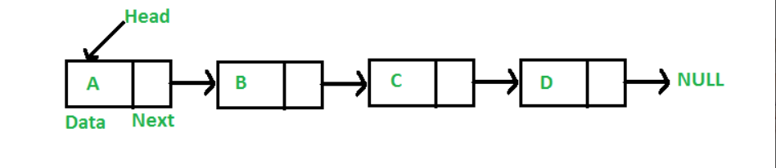

Using linked list, we created various nodes for each patient and each node is been linked to previous node and next node. Each node contained name, address, contact number, age, id, health status etc.

Functions used in linked list are:

1. creation of node,
2. deletion of node,
3. linking of node,
4. insertion of node

**4.2 ARRAYS**

An array is a collection of items stored at contiguous memory locations. The idea is to store multiple items of the same type together. This makes it easier to calculate the position of each element by simply adding an offset to a base value, i.e., the memory location of the first element of the array.

In some cases, it isn’t recommended to create a linked, so arrays are used as a replacement, for data handling. Arrays provide least coding as compared to linked list and greater benefits. They are used in storing the names of areas in pune. Character arrays are used to store names and address of patients and also used for conversion purposes.

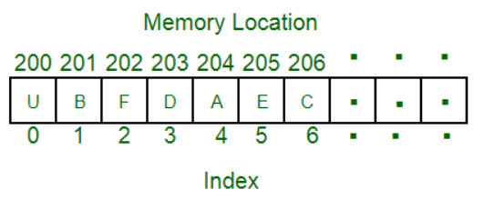

**5. DIGITAL ELECTRONICS AND LOGIC DESIGN**

According to our project theme, we want to add daily patients name who have been tested covid-19 positive and also delete or subtract patients name who have recovered completely or patients who have died.

For this purpose, we have implemented digital electronics concepts, such as binary addition or subtraction and for converting decimal number to binary number or vice versa we are using BCD to Binary conversion concept. After using these concepts in our project, we can easily insert decimal number and obtain decimal output, there is no need to insert binary number in any part of the program.

**5.1 BINARY ADDITION / SUBTRACTION:**

It is the most commonly used digital electronics concept. In which two binary numbers are added by using rules of binary addition. Binary addition is much similar to our normal everyday addition (DECIMAL ADDITION), except that it carries on a value of 2 instead of a value of 10. For Example, in decimal addition if you add 8+2 then we get addition result as 10. Something similar happens in case of binary addition.

In binary number system there are only two numbers 1 or 0. We can add these two numbers in different sequences.

RULES FOR BINARY ADDITION

1. 0+0 = 0, here both numbers are zero then we get answer as 0.
2. 0+1 = 1, here first number is 0 and we add 1 in it so we get answer as 1.
3. 1+0 = 1, here first number is 1 and we add 0 in it so there isn’t any change, hence answer is 1.
4. 1+1 = 0 and carry is 1, here both numbers are 1 so answer that we could expect in decimal number system is 2, but in binary 2 is represent as 10 so we get answer as 0 and carry as 1, this carry output will be added into further addition blocks.

Like Binary addition we are going to subtract two binary numbers, for that subtraction consider following sequences.

RULES FOR BINARY SUBTRACTION

1. 0-0 = 0, here both numbers are zero so subtraction is also 0.
2. 0-1= 0 and borrow 1, here first number is 0 and we are going to subtract 1 from that 0, so we get 0 as answer and we need to borrow 1 from another nearest subtraction block.
3. 1-0=0, here first number is 1 and we want to subtract 0 from that 1, so there is no any change and answer as 1.
4. 1-1=0, here both numbers are 1 so answer of subtraction is 0.

By using above all binary addition and subtraction condition we are going to implement binary addition and subtraction code.

But binary addition/subtraction concept is termed under the condition that we have to insert only binary digits for every simple entry in the project, it’s quite tough to always make binary number entry in the project, hence we are using BCD to Binary and Binary to BCD conversion concept in our project. For maintaining simplicity in the project, we are implementing this point in the program.

**5.2 DECIMAL TO BCD CONVERSION:**

In the BCD numbering system, a decimal number is separated into four bits for each decimal digit within the number. Each decimal digit is represented by its weighted binary value performing a direct translation of the number. So, a 4-bit group represents each displayed decimal digit from 0000 for a zero to 1001 for a nine.

So, for example, 35710 (Three Hundred and Fifty-Seven) in decimal would be presented in Binary Coded Decimal as:

35710 = 0011 0101 0111 (BCD)

The BCD is a weighted code and the weights used in binary coded decimal code are 8,4,2,1, commonly called the **8421 code** as it forms the 4-bit binary representation of the relevant decimal digit.

**5.3 BCD TO DECIMAL CONVERSION:**

The conversion from binary coded decimal to decimal is the exact opposite of the above. Simply divide the binary number into groups of four digits, starting with the least significant digit and then write the decimal digit represented by each 4-bit group. Add additional zeros at the end if required to produce a complete 4-bit grouping. So, for example, 1101012 would become: 0011 01012 or 3510 in decimal.

The conversion of BCD-to-decimal or decimal-to-BCD is a relatively straight forward task but we need to remember that BCD numbers are decimal numbers and not binary numbers, even though they are represented using bits.

By using above all concepts, we managed to record the patient’s entries into the respective hospitals and also delete patients from the hospitals. Thus, we are using Digital Electronics concepts in the project as per the above manner.

**6. OBJECT ORIENTED PROGRAMMING**

Object Oriented Programming Concept is one of the most required skill set in 2020. It teaches us the core working of object interaction and its implementation. As Concerned about the project, the project holds the most vital factors of object-oriented programming such as creating a user defined data type named “class” and “Structure”, creation of objects of a class, using static variables, dynamic memory allocation, type conversion, file handling etc.

**6.1** **CLASS**

A class in C++ is the building block, that leads to Object-Oriented programming. It is a user-defined data type, which holds its own data members and member functions, which can be accessed and used by creating an instance of that class. A C++ class is like a blueprint for an object. An **Object** is an instance of a Class. When a class is defined, no memory is allocated but when it is instantiated (i.e., an object is created) memory is allocated.

In this project we have performed the class creation steps and its object creations as well. The objects hold different instance of the class, using this as an advantage we have implemented many such objects to hold record of the patients found Covid-19 positive.

**6.2** **STRUCTURE**

A structure creates a data type that can be used to group items of possibly different types into a single type, this helped us in grouping the name, address, age, gender, id

And Health status of the patient. Grouping, in turn Resulted in an organized report calculation and its manipulation.

**6.3** **STATIC VARIABLES**

Static variables have a property of preserving their value even after they are out of their scope. Hence, static variables preserve their previous value in their previous scope and are not initialized again in the new scope.

Accordingly, static variables are used in the program for managing the count of patients Allotted/Recovered/Dead.

**6.4** **DYNAMIC MEMORY ALLOCATION**

Dynamic memory allocation in C/C++ refers to performing memory allocation manually by programmer. Dynamically allocated memory is allocated on **Heap** and non-static and local variables get memory allocated on **Stack**.

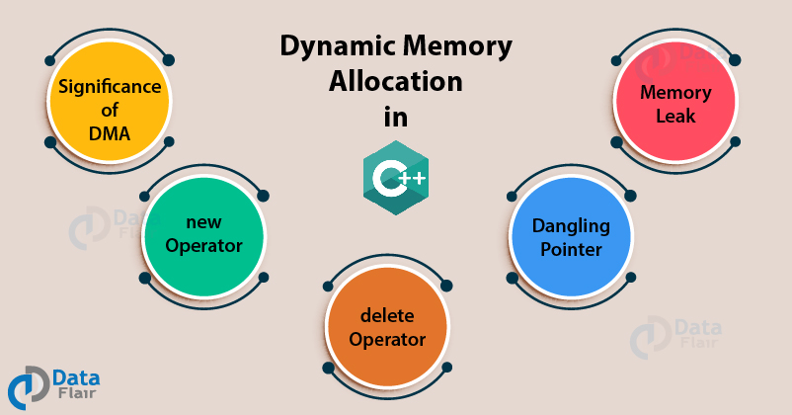

Using dynamic Memory allocation, we are with greater ease for allocating memory to the newly added patients and deallocating memory when the patient is dead/ recovered. This truly reflected in the memory management of the program and its Smooth working.

Dynamic memory Allocation even avoided the Errors of “MEMORY FULL”, Which are often faced due to static allocation

**6.5 TYPE CONVERSION**

A type cast is basically a conversion from one type to another. There are two types of type conversion:

1. **Implicit Type Conversion**
2. **Explicit Type Conversion**

In the project the implicit conversion technique conversion is used. This made the calculation easier.

Also, various other conversion such as string to integer (stoi), string to double, string to character array (.cstr()) are used.

**6.6 FILE HANDLING**

In C++, files are mainly dealt by using three classes fstream, ifstream, ofstream available in fstream header file.

1. **ofstream:** Stream class to write on files.
2. **ifstream:** Stream class to read from files.
3. **fstream:** Stream class to both read and write from/to files.

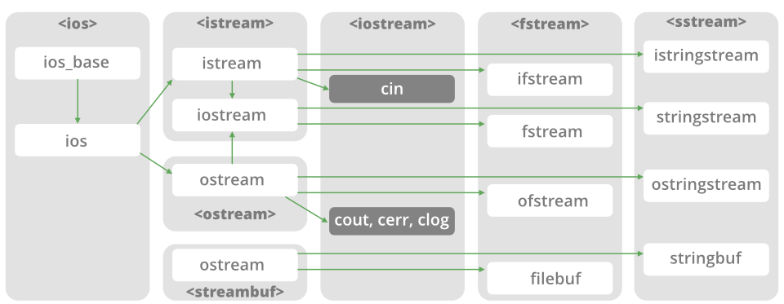

File Handling concept is used for storing the patients record in a specified format. The patient’s entries are stored in the “Entries.txt”, recovered patients are stored in “recover.txt” and Deaths are stored in “Death.txt”. Using the concept of file handling we are able to store the data in secondary memory and retrieve it for further calculations and management.

File handling concept also helped us in getting a hands-on experience with operations and advantages of files handling with various read write operations.

Operations Performed on File:

|  |  |
| --- | --- |
| **Function** | **Description** |
| open () | It is used to create a file. |
| close () | It is used to close an existing file. |
| read () | It is used to read data from file. |
| write () | It is used to write data into file. |

**7. Computer Graphics**

The term computer graphics includes almost everything on computers that is not text or sound. Today almost every computer can do some graphics, and people have even come to expect to control their computer through icons and pictures rather than just by typing

By using the concepts of computer graphics our motive is to provide you with a graphical display so that you can interpret more easily and conveniently. Computer graphics gave a new dimension to the designing of the project. We have provided users the comfort of map representation of Red/Green/Yellow zones. Using map one can view the different zone allocations in different parts of pune.

* 1. **MAP**

By using concepts of polygon filling, we created a graphical map of Pune in the console window. This shows the area wise zone representation as red / green / yellow.

If the number of patients exceed a specified limit then the region is marked as red zone and restrictions are imposed on that area by the local police. The Map also shows the nearest Covid-19 hospitals for the testing and admission of patients. Hospital’s empty and allotted beds are also displayed so that the local public can view the situation of beds in a particular hospital.

People can also view today’s and previous admitted patients, recovered patients and dead patients.

Functions used in graphical window:

Setfillstyle (style, color): for filling style and color.

Outtextxy (x, y,” string”): To display text on screen.

Fillellipse (x, y, x_rad, y_rad): For circle filling with x_rad=y_rad=5;

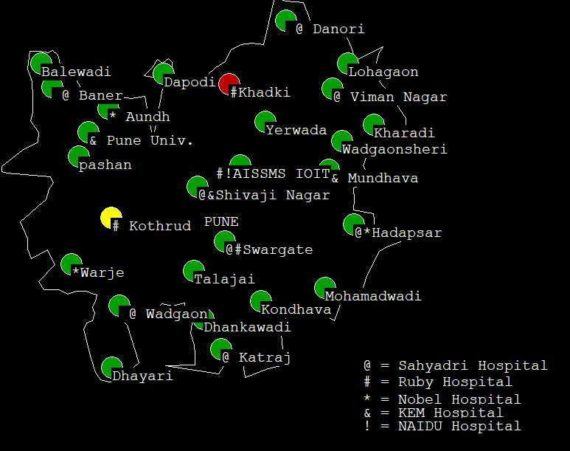

* 1. **GRAPHICAL USER INTERFACE**

It is one of the most growing sectors of computer engineering.

Window forms are been designed and used to make the project look more attractive from the user side. It includes admin login and user login where admins have the authority to access the private data and edit it. Users can only view the non-editable content.

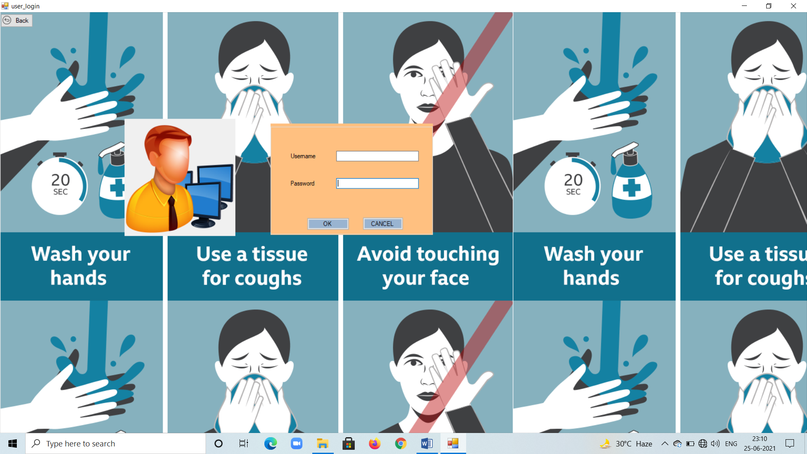

**8. MATHEMATICS**

Almost every single calculation whether it be from declaring a variable to using it, mathematics is required. hence without maths coding isn’t possible. Therefore, concepts of basic maths such as incrementation/decrementation, addition, subtraction, multiplication, division and set theory are used.

**8.1 SET THEORY**

Set theory is a branch of mathematical logic that studies sets, which informally

are collections of objects. Although any type of object can be collected into a set, set theory is applied most often to objects that are relevant to mathematics. The language of set theory can be used to define nearly all mathematical objects.

Set theory is used for the graphical representation of Active / Recovered / Dead Patients. It is also used to display the hospital list of remaining and allotted beds.

SET A= REGISTERED CASES WHICH IS A UNIVERSAL SET

SET B= ACTIVE CASES

SET C= RECOVERED CASES

SET D= DEATH CASES

SET A = SET B U SET C U SET D

**|B| = |A| - (|C| + |D|)**

Allotted Hospital Beds =30

Hospital Beds Remaining =30-| B |

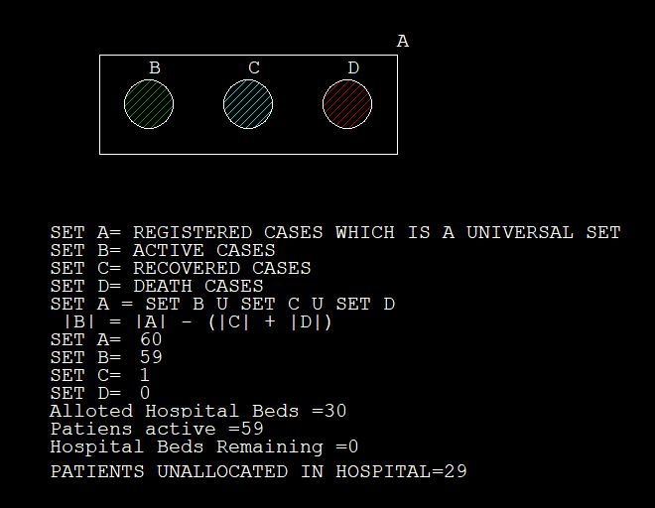

**9. SCREEN SHOTS**

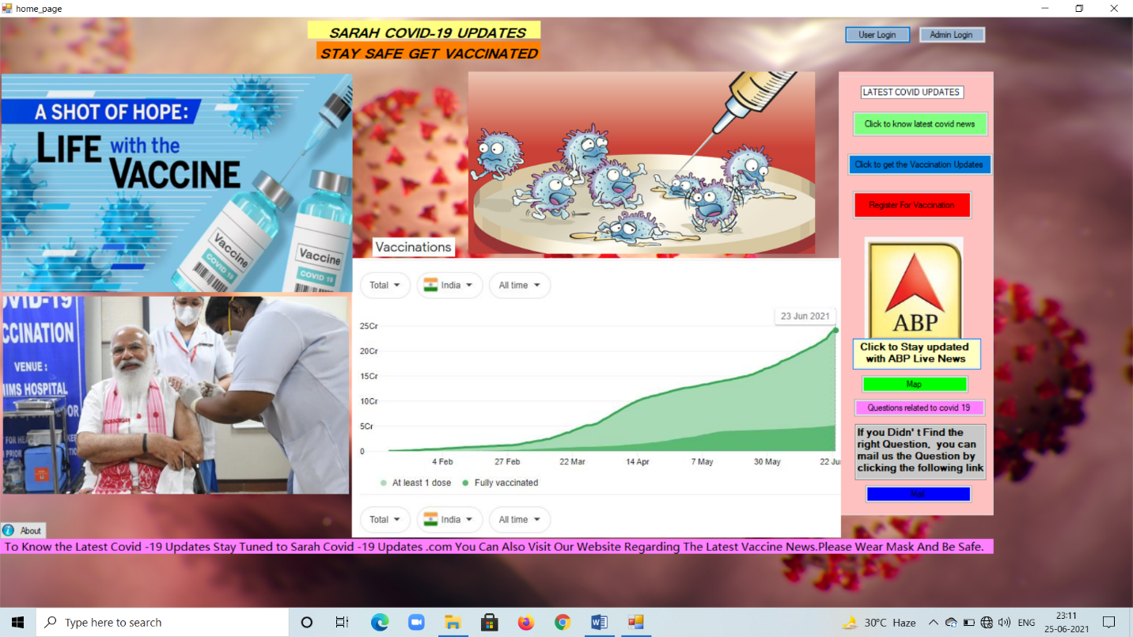

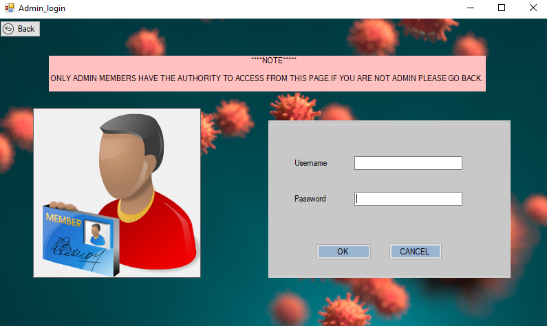

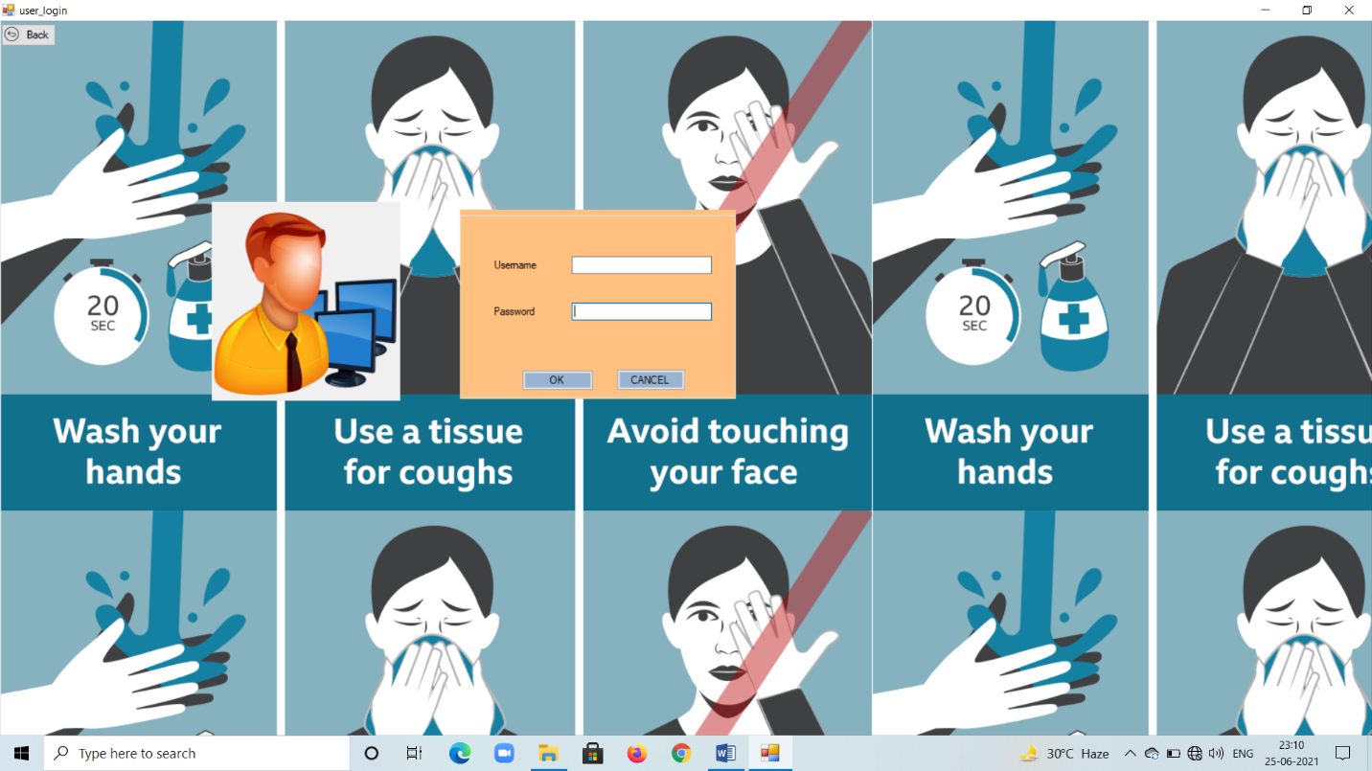

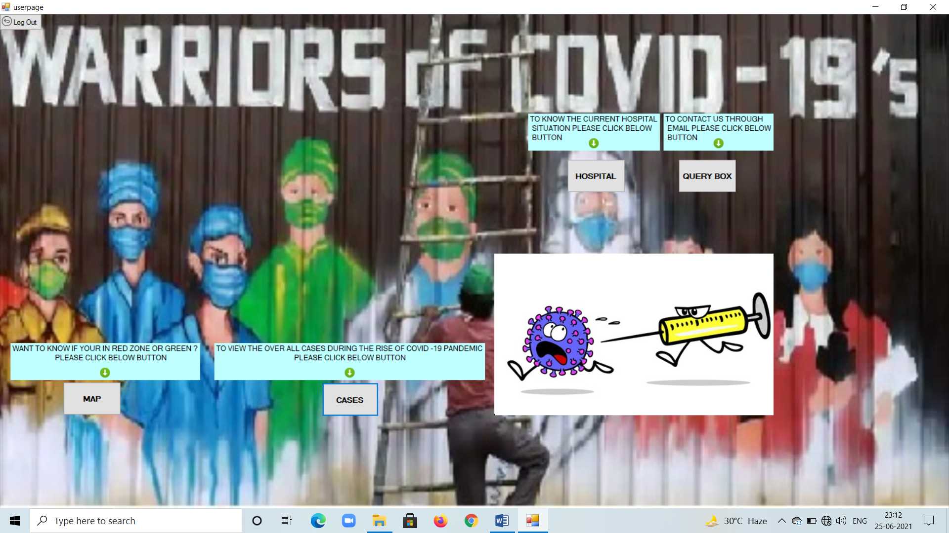

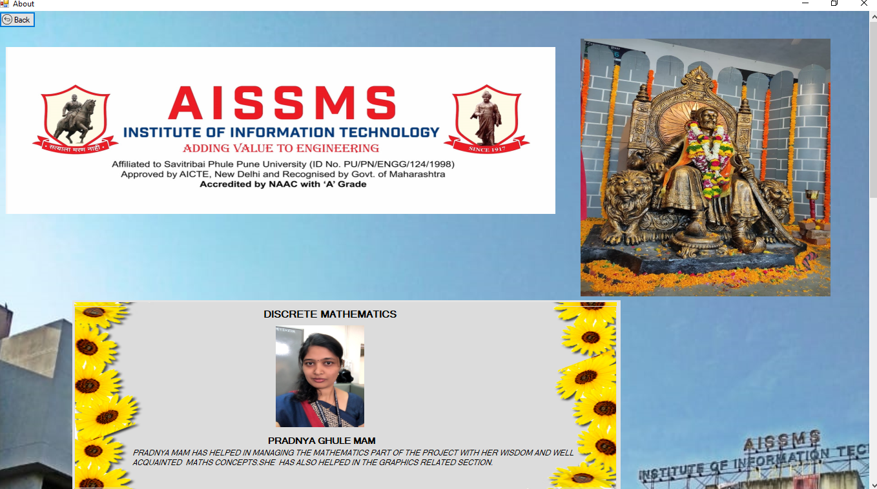

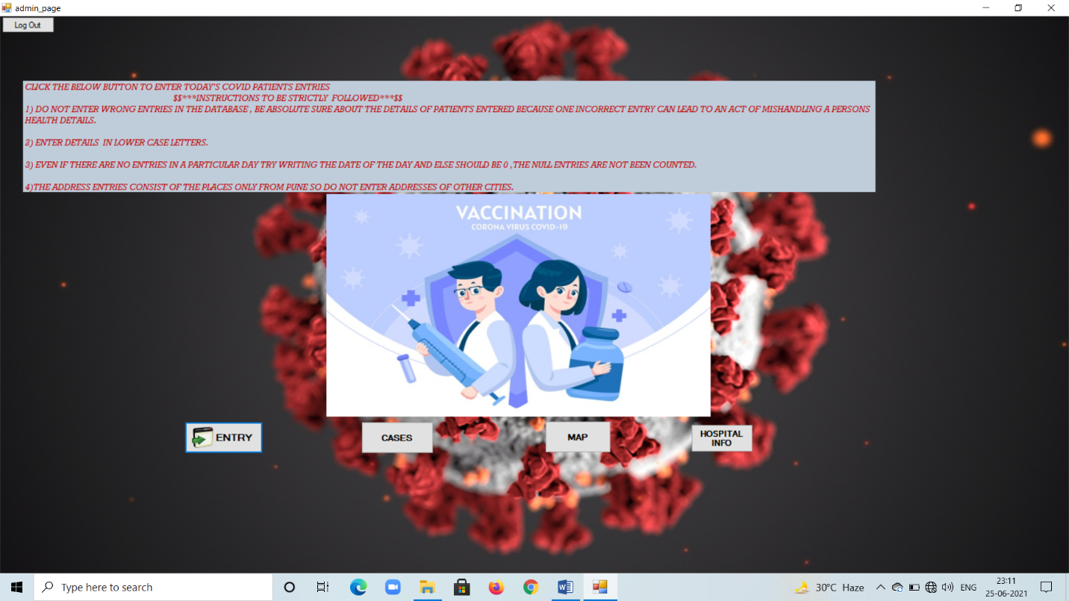

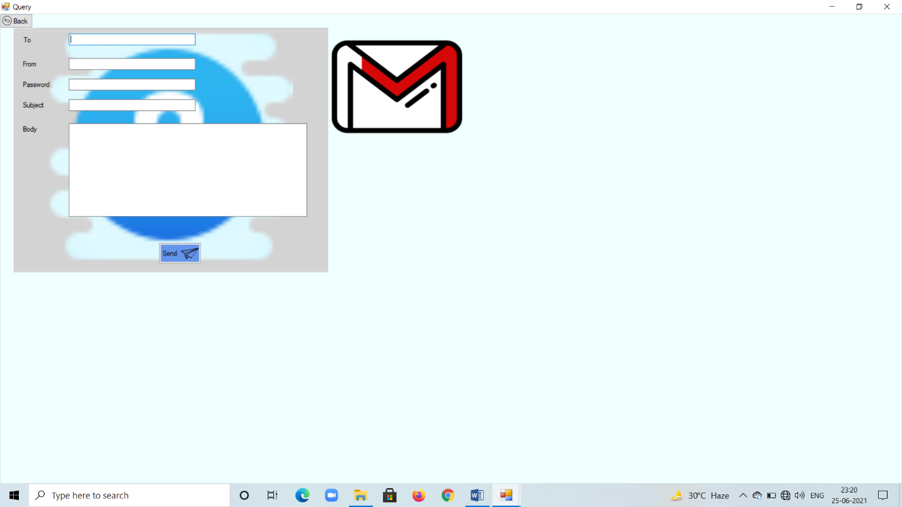

**10. Advantages of System:**

1. This System helps in maintaining the day-to-day entries of patients found Covid-19 positive.
2. It helps in knowing the zone wise restriction imposed on the local residences.
3. The present Situation of Hospital Beds are displayed.
4. Public people and Common man can now review the Active / Dead / Recovered Covid-19 patients.
5. The System can also display the nearest hospital, where covid patients are treated.
6. Through this system one can also contact our managing executive to know current conditions and also if he/she wants to get a covid check-up.
7. Online 24x7 service is available with our contact staff.
8. System has provided admins the ease to search patients allotted and know the required details.
9. Covid patients are categorized on the basis of their present address.
10. Unauthorized access in denied.
11. People can now get new updates regarding the covid-19 vaccine.
12. The Application can run on any windows-based system i.e., win XP/7/8/8.1/10.
13. Admins can now delete patients easily, with an option for recovery or death.
14. It a useful tool against covid-19 virus.
15. Users can also register for vaccination through this interface.
16. Users can visit and clear their doubts regarding the Covid-19 by visiting our question/answer section.
17. It is an exemplary tool for getting latest Covid news.
18. Users can reach out to our management executive by mailing, in case of any query, thorough our query section.

**11. Disadvantages of System:**

1. System is unable to interpret UPPER CASE letters, hence everywhere lower casing is used.
2. It can only display records from pune.
3. Records are maintained in a text file rather than in an online database.
4. Text files are more vulnerable.
5. It can’t work on mac and Linux operating system. Even working on android platform is not possible.
6. Limitations of map, it only displays map of pune.
7. Hospital database is limited and only restricted to pune.
8. When it comes to security, it lacks and can’t prevent hackers from manipulating the data.
9. It uses Command prompt for its execution, which is an outdated concept for using this system.
10. It consumes about 300 MB of the system available ram; hence it cannot run on older or slower machines.
11. Even if there are in a particular day try writing the date of the day and else should be 0, the NULL entries are not been counted.
12. It is not storing the databases of vaccination.

* **BUT ABOVE ALL THESE DISADVANTAGES THE BIGGEST ADVANTAGE IS THAT, IT HELPS THE SOCIETY TO FIGHT AGAINST THE PANDEMIC, WHICH IS WHY WE BUILT THIS SYSTEM.**

1. **Applications of Project**

* As this project is concerned about the pandemic corona virus its main aim is to track down the patients and provide reliable and trust worthy information to the common people.
* It can also be used to track many diseases including dengue, malaria, swine-flu etc.
* In near future, there will be many such situations like the coronavirus, where this system is useful in the health industry.
* By overcoming its disadvantages through building similar and more efficient system, one can even track whole countries health status and prevent further viruses from spreading.
* This System can prove a boon to the health industry and also help the Ministry of Health and Family Welfare, Government of India.
* This system is also helpful for providing Medicare and treatment to the under privileged ones and the affected ones.
* It will also be helpful in providing health checkups at regular intervals. The NGO’s can also benefit from this system.

1. **CONCLUSION:**

As per the requirement of the society, of having a health care system, this system has compiled with its terms and provides results as per expected. This project meets the need, of having a reliable software for tracking corona patients and its spread.

Even though it is a small-scale system, it can give its major contribution during this pandemic and can prove useful in its times. More efforts can make this system a completely reliable and future ready for further health related havocs.

Our future will be experiencing many such situations, not hope so, but this is a blooming truth, where in this system will be useful and can greatly benefit the society as concerned about their health.

1. **CONTRIBUTION**
2. **REFERENCES:**

YOUTUBE LINKS

1) FUNDAMENTALS OF DATA STRUCTURE

* 1. SINGLE LINKED LIST

<https://youtu.be/o1QaGUEi6ew>

* 1. ARRAYS

<https://youtu.be/SPuS9UJF1lo>

1. DIGITAL ELECTRONICS AND LOGIC DESIGN
   1. BINARY ADDITION/SUBTRACTION

<https://youtu.be/5F6orbqZigI>

<https://youtu.be/OHf0Eg9ZhGQ>

* 1. DECIMAL TO BCD CONVERSION

<https://youtu.be/AM0tr8Kyvzg>

* 1. BCD TO DECIMAL

<https://youtu.be/-cnTpRPoO9w>

1. OBJECT ORIENTED PROGRAMMING

3.1 CLASS

<https://youtu.be/ABRP_5RYhqU>

3.2 STRUCTURE

<https://youtu.be/XBFGsKQX21s>

3.3 STATIC VARIABLES

<https://youtu.be/-WRllQLW8RE>

3.4 DYNAMIC MEMORY ALLOCATION

<https://youtu.be/-0Wo4v0g_pY>

3.5 TYPE CONVERSION

<https://youtu.be/SBcIjz3cy3k>

* 1. FILE HANDLING

<https://youtu.be/CpFx-5J7D7s>

1. COMPUTER GRAPHICS
   1. MAP

<https://csprograms4u.blogspot.com/2018/03/designing-of-map-of-india-in-computer.html>

* 1. GRAPHICAL USER INTERFACE

<https://youtu.be/Oxg6ciIcO3U>

1. MATHEMATICS

5.1 SET THEORY

<https://youtu.be/XbCBbJncfGE>

……...THANK YOU FOR YOUR VALUABLE TIME!